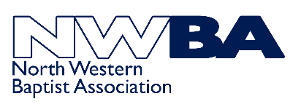 | 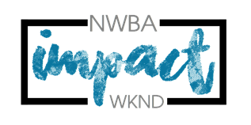 | Impact Activities Weekend  Group Booking Form  13th - 15th October 2023
Please return this form to impact@nwba.org.uk A non-refundable deposit of £40 per person is required to reserve your group booking. Total cost is £110 per person. Bank transfers (our preferred payment option) can be made using the following details: Account Name: North Western Baptist Association Account # 20246488 Sort Code 60-83-01 using individual payment reference [SURNAME] Impact21 or group payment reference [CHURCH NAME] Impact21

Church
Group Leader
Home Address
Telephone
Email
☐ Please tick if you would like us to notify you of future activities

Each group needs to have at least 2 Youth Leaders with them.
YOUTH LEADERS MUST BE OVER 18 YEARS OF AGE
If you are bringing a mixed group, please try to ensure you have a male and female leader)

Name of Youth Leaders | Male / Female | Deposit Enclosed Yes / No

Name of Young Person | Male / Female | Date of Birth | Age at 13/10/23 | Deposit Enclosed Yes / No
(Please add multiple names in the final box if you require space for more young people)
Bookings: Terms & Conditions

Places are allocated on a first come, first served basis with a £40 NON- REFUNDABLE deposit.

The total cost is £110. Final booking date Sunday 30th July 2023

Cancellation must be made in writing and is only effective on the date received. If cancellations are made after 30th July 2023, the full amount will be payable. Places cannot be held without the deposit. We apologise for having to introduce these conditions, but activities and accommodation must be paid for in advance and Quinta and our activity provider, Venture Out charge the above rates for cancellation of places.

If any of your young people have additional needs, please let us know as early as possible so that we can work with Quinta and our activity provider to ensure relevant provision is put in place.

Data Protection Statement
Under Data Protection legislation the Charity Trustees of the North Western Baptist Association are the Data Controller and can be contacted by ringing 01942 221595 or emailing dataprotection@nwba.org.uk

We are collecting this information to enable the NWBA to run the Impact Activities Weekend safely and ensure we can contact you.

Data Protection legislation allows us to process this information as we regard it as being in the Association’s legitimate interest. If you are unable to supply the information requested then we will be unable to accept your application to attend the weekend.

The information you supply will be held in paper form in a folder which will be kept in a securely locked cupboard in the Association office. Information will also be stored electronically on the Association Sharepoint which is password protected and accessed only by the NWBA Team. This information may be shared with the Impact Team as appropriate for the sole purpose of running this event.

We will destroy data in accordance with NWBA’s Data Retention Policy. If you have ticked the box asking us to keep you informed about future activities we will retain your details for the sole purpose of notifying you of such events. We will NOT pass on this information to anyone else. You have the right to ask to be removed from this circulation list at any time.

If you are concerned about the way your information is being handled please speak to our Data Protection Trustee. If you are still unhappy you have the right to complain to the Information Commissioners Office.

