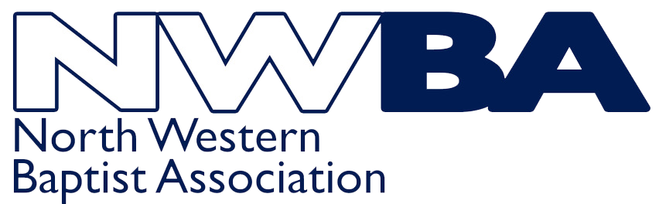 | 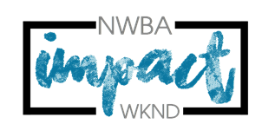 | Parental Consent & Medical Form  (for Under 18s)  9th – 11th October 2026
This form must be completed by a parent/guardian for each young person to participate in the weekend. It should be completed and signed before returning it to your Youth Leader. The original signed copy must be held by the Group Leader and brought along to the weekend. A scanned copy of the completed form should be emailed to impact@nwba.org.uk by no later than 31st July 2026.

Youth Leaders from each church are responsible for looking after the young people in their care during the weekend, and administering any medication, if necessary. If your child has any health, medical or other needs please ensure you note these on the form and that your youth leaders are aware of anything prior to the weekend.

Child’s Full Name |  |  |  |  | Male ☐/Female ☐
Home Address
Hm Telephone |  |  | Mobile Number
Date of Birth |  | National Health No

Emergency Contact 1 (person to contact in case of emergency during the weekend):
Full Name
Relationship to YP
Address
Hm Telephone |  | Mobile Number

Emergency Contact 2 (person to contact in case of emergency during the weekend):
Full Name
Relationship to YP
Address
Hm Telephone |  | Mobile Number

Does s/he have dietary requirements? YES ☐ NO ☐ (Please tick as applicable)
If YES, please give details (ie vegetarian, gluten free etc)

Does s/he suffer from any allergies? YES ☐ NO ☐ (Please tick as applicable)
If YES, please give details (ie is this a life-threatening allergy, are there signs and symptoms youth leaders need to be aware of). Please describe any relevant medical condition / history

Has s/he been vaccinated against tetanus? YES ☐ NO ☐ (please tick as appropriate) Date: _________________

Please describe any relevant medical conditions/history

Will s/he be in possession of any medication during the weekend? YES ☐ NO ☐ (Please tick as applicable)
If YES, please give details (ie Ritalin, anti-convulsion medication, inhalers, paracetamol, anti-histamine etc)

Does s/he have any disability that we should be aware of?

Is there any other information about this young person that would be helpful for us to know?

Do you give permission for your child’s photo to be taken during the weekend? | YES ☐ NO ☐
(Photos may be used for publicity purposes) | (please tick as applicable)

If you have had to use additional sheets, please sign each additional sheet with your child’s name at the top.

Please note that this declaration can only be signed by those with parental responsibility.
- I give permission for ______________________________ (insert name) to take part in the Impact Activities Weekend, including the activities programme run by NWBA or Venture Out.
- I consider my son/daughter to be medically fit to participate in the activities
- I give permission for my son/daughter to be given one paracetamol tablet/medicine, should the youth leaders deem it necessary YES ☐ NO ☐ (if any other doses are required, we will contact a parent)
- In an emergency and/or if I cannot be contacted, I am willing for my child to receive necessary hospital or dental treatment including an anaesthetic YES ☐ NO ☐ (please tick)

I UNDERTAKE TO INFORM THE LEADER SHOULD ANY OF THE ABOVE INFORMATION CHANGE BY THE DATE OF THE EVENT.

Signed _____________________________________________
(Parent or Adult with parental responsibility)

Print name

Date

Data Protection Statement
Under Data Protection legislation the Charity Trustees of the North Western Baptist Association are the Data Controller and can be contacted by ringing 07821 645265 or emailing dataprotection@nwba.org.uk

We are collecting this information to enable the NWBA to run the Impact Activities Weekend safely and ensure we can contact you (or other nominated adult) in case of an emergency.

Data Protection legislation allows us to process this information as we regard it as being in the Association’s legitimate interest. If you are unable to supply the information requested then we will be unable to accept your child’s reservation on the weekend.

The information you supply will be held in paper form in a folder which will be kept in a securely locked cupboard in the Association office. Information will also be stored electronically on the Association Sharepoint which is password protected and accessed only by the NWBA Team. This information may be shared with the Impact Team, your youth leaders and the activity providers as appropriate for the sole purpose of running this event.

We will destroy data in accordance with NWBA’s Data Retention Policy. We will NOT pass on this information to anyone else.
If you are concerned about the way your information is being handled please speak to our Data Protection Trustee. If you are still unhappy you have the right to complain to the Information Commissioners Office.

