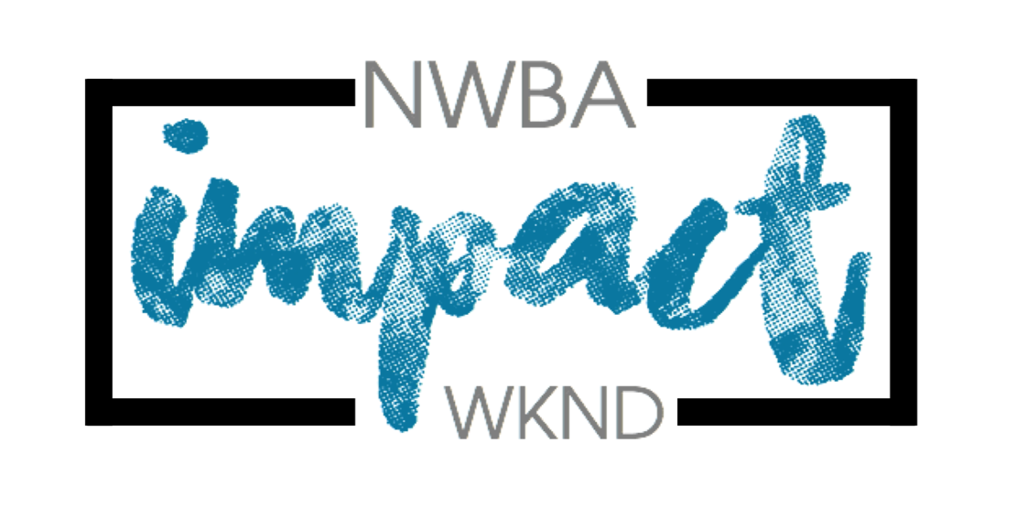
Young Leaders Team for
NWBA Impact Weekend
13th – 15th October 2023

Are you aged 16+ ?
Why not join the Impact team as a young leader?
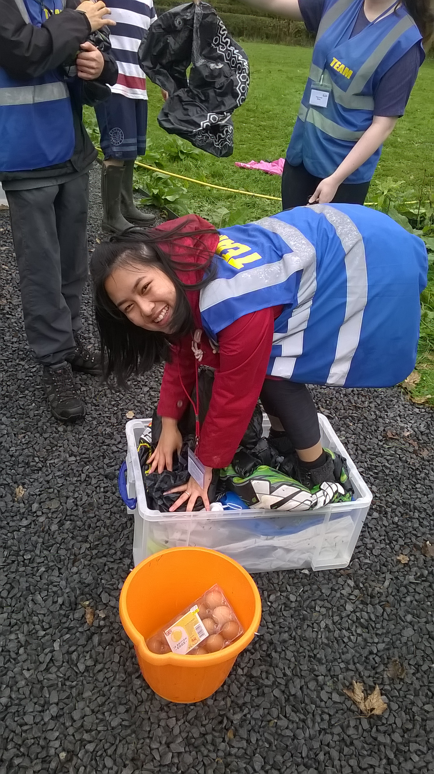
You will have the opportunity to:
- Gain general hands on experience as you assist the highly experienced Impact Team in running the weekend

- Choose to focus some of your time in some of the following areas: outdoor activities, catering, music, creative arts…
- If you successfully complete the training you will receive a certificate from the North Western Baptist Association

- Finally, you’ll be given the opportunity to participate in a longer discipleship programme run by the NWBA called {Disciple}
(see nwbayouth.com for details)

Being part of the leading of a youth weekend requires some up-front leadership skills, but much of it is about having a servant heart, and ensuring the smooth running of the weekend for the other young people.

You will also be able to take part in some of the activities and the worship and word sessions.

There will be no cost to you apart from your energy for the weekend.

If you are accepted as a young leader you will be invited to attend a training day
prior to the Impact Weekend. This will include an opportunity to get to know the team, planning for the weekend and some leadership training. We will let you know the date and venue for this as soon as it is confirmed.

If you would like to be part of the Young Leaders Team this year at the Impact Weekend, October 13th-15th, please complete this form and return it to Jonny Hirst by 3rd September 2023 …(Or enroll of NWBA {Disciple} instead)
If you have any questions please don’t hesitate to get in touch
jonnyh@nwba.co.uk (Regional Minister for Youth)
Check out the website www.nwbayouth.com

NWBA, The Resource Centre, Fleet Street, Wigan, WN5 0DS

Data Protection Statement
Under Data Protection legislation the Charity Trustees of the North Western Baptist Association are the Data Controller and can be contacted by ringing 01942 221595 or emailing dataprotection@nwba.org.uk
We are collecting this information to enable the NWBA to run the Impact Activities Weekend safely and ensure we can contact you.
Data Protection legislation allows us to process this information as we regard it as being in the
Association’s legitimate interest. If you are unable to supply the information requested then we will be unable to accept your application to attend the weekend.
The information you supply will be held in paper form in a folder which will be kept in a securely locked cupboard in the Association office. Information will also be stored electronically on the Association Share-point which is password protected and accessed only by the NWBA Team. This information may be shared with the Impact Team as appropriate for the sole purpose of running this event.
We will destroy data in accordance with NWBA’s Data Retention Policy. We will NOT pass on this
information to anyone else.
If you are concerned about the way your information is being handled please speak to our Data Protection Trustee. If you are still unhappy you have the right to complain to the Information Commissioners Office.
Application for Young Leaders Team 2023
(IF YOU HAVE ALREADY ENROLLED ON {DISCIPLE} YOU DO NOT NEED TO COMPLETE THIS FORM)

Name:
Date of Birth & Age (by 1st Sept 2023):
Address:

E-mail:
Phone Number:
Church:
Please put in number order which of the following you would be interested in helping to lead (1 most interested, 7 least interested)
- Activities
- Art & Craft
- Cooking
- Leading Team Games
- Health and Safety / Security
- Worship (You need to be able to play an instrument or sing to a competent standard, as rehearsal time at the weekend is very limited)
  - What instrument(s) do you play?
- Performing Arts

I would like to attend the Impact Youth Weekend as a young leader, I understand that I will be working under the guidance of the Impact Team.

Signed:
Parent/Guardian Signature:
(if young leader is under 18):
See next page to fill in medical information. Page 1 of 3

Young Leader Health and Medical Information

Name:

GP’s Name: ________________ Surgery Telephone:_______________
Do you suffer from any allergies? If YES please give details

Are you on any medication or any other treatment? If YES give details

Do you use an inhaler? If YES, which type

Please describe any medical conditions / history that we ought to be aware of:

When was your last Tetanus given (Year):

Was the primary course and booster completed? YES / NO (please delete as applicable)

In an emergency I am happy to receive any hospital treatment including an anaesthetic
YES / NO (please delete as applicable)

Are you on a special diet (e.g. gluten free, vegetarian) if YES give details

Please give the name and address of next of kin who can be contacted in the event of an emergency:

Next of Kin Telephone number:

- I confirm that the above information is correct and up to date
- I confirm that I am physically fit to participate in the Impact Activities Weekend

Signed (young leader): ____________________ Date: ____________________

Print Name: ____________________________

Signed (Parent, if under 18): _________________ Date: ____________________

See next page for references section. Page 2 of 3

Please could you give the name and address of two people who we could contact for a character reference, at least one of these should be your minister or youth leader.

Name
Address

E-mail
What is your relationship to this person?

Name
Address

E-mail
What is your relationship to this person?

Once we have received your references, someone from the Impact Team will be in touch regarding further information about the training day.
The Impact Team look forward to having you join us this year.
Page 3 of 3

