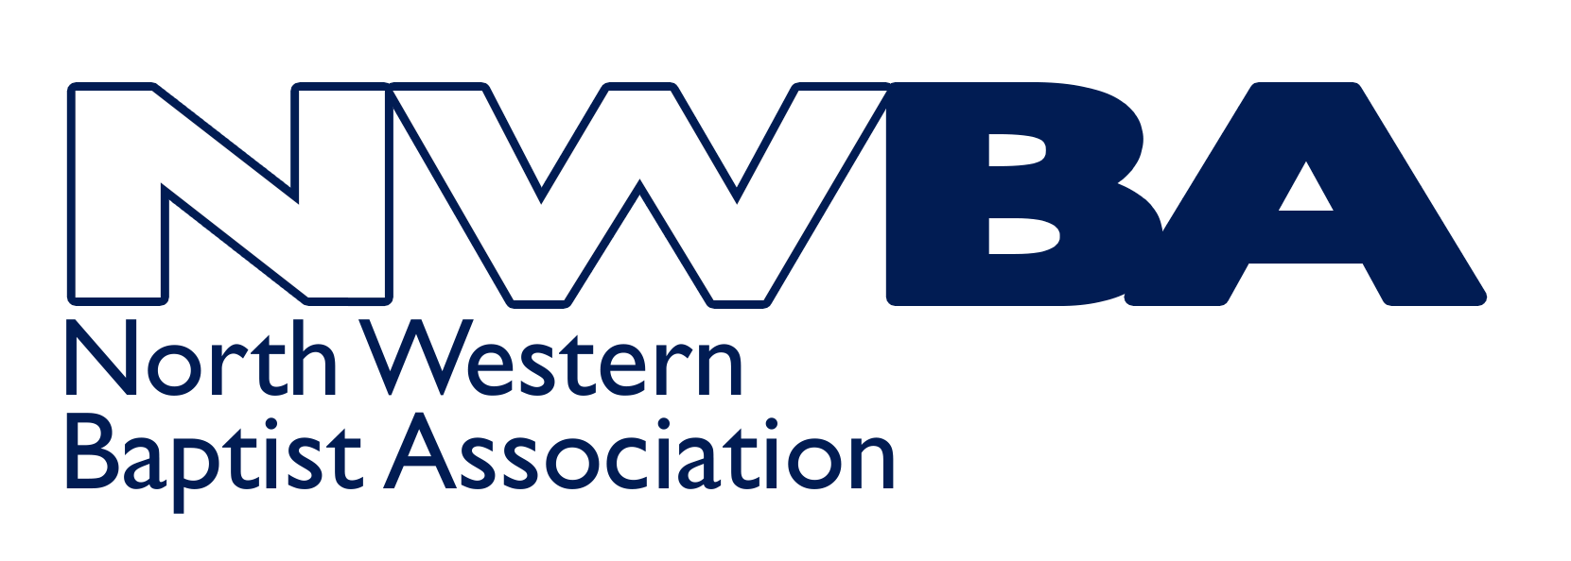 | 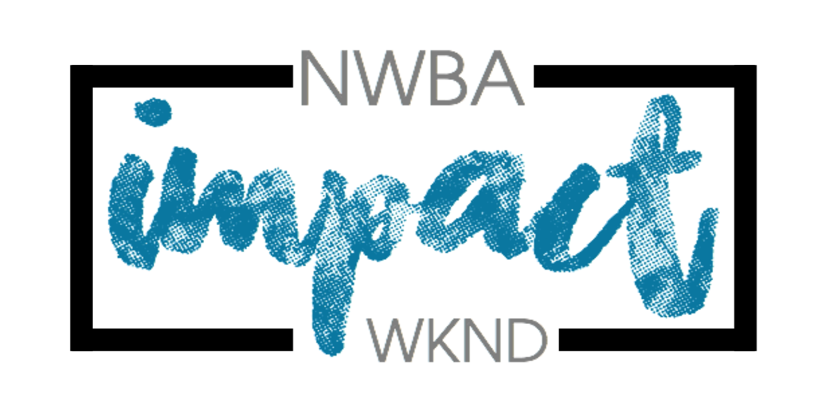 | Impact Activities Weekend  13th – 15th October 2023

Please read Youth Leaders Guidance/Information prior to signing this, and ensure your Minister/Church Secretary has read and signed it as well.

Full Name
Date of Birth
Home Address
Telephone
Email
Date of enhanced DBS relating to Children’s and/or Youth Work

Youth Leader:
I have read and understood the Youth Leaders’ Guidelines/Information and accept that I will be responsible for the young people in my care throughout the weekend
Signed
Date

To be completed by Minister / Church Secretary:
Name of Church

I confirm that the church is sending the above-named Youth Leader to the Impact Activities Weekend as a Leader of the Young People from this Church.

I confirm that he/she has been verified according to our Safeguarding Procedures.
Signed | Minister / Church Secretary [please delete as appropriate]
Date

Please scan and return the completed signed copy to impact@nwba.org.uk

Impact Activities Weekend
13th – 15th October 2023

Youth Leaders’ Guidance/Information

Impact Team
The Impact Team are a group of volunteers and staff from the NWBA. Their primary role both before and during the weekend is to coordinate and run the programme for Young People (aged 11-16 at secondary school) and their Youth Leaders. The aim of the Impact Activities Weekend is to organise a fun, action packed programme that enables youth leaders to spend quality time with their youth group

Church Youth Leaders
It is the Youth Leader’s responsibility to supervise their young people for the entirety of the weekend. This includes if a young person needs to be taken off site or sent home. You are also the first port of call for your young people overnight (e.g. if they are unwell). It is vital that leaders stay on site for the whole weekend.

Youth Leaders are expected to work together with the Impact Team to ensure everyone has a good experience during the weekend. This will include supervising and assisting with tasks such as washing up at the end of meals, tidying bedrooms etc. All Youth Leaders must be over 18 years of age.

Ratio of Youth Leaders to Young People
The minimum ratio we recommend, in line with Safe to Grow is 1:8. However, this is dependent upon the age, maturity, behaviour or individual needs of the young people you are bringing. It may be necessary for you to bring more leaders to ensure your young people are adequately supervised and their needs met. If you are bringing a mixed group of boys and girls, then you will require both a male and female leader.

Safeguarding
To come to the Impact Weekend, you must have an enhanced DBS for working with children/young people. You must also have the agreement of your Trustees (Deacons) that they are sending you as their church representatives to work with and supervise the young people from your church.

NWBA will have a Safeguarding Officer on site for the duration of the weekend should any safeguarding/child protection issues arise. Please ensure the Youth Leaders Agreement is completed and returned to the NWBA office (by post – an original signature is required)

Other than drop off/pick up, No adult should attend at any point during the weekend without having first completed the appropriate consent and health forms.

Leaders Sleeping Arrangements
Leaders will be sharing sleeping accommodation (dormitories) with other leaders. If there is a good reason why you would not want to share, please let us know. We cannot promise that separate sleeping accommodation can be found, but we will do our best.

Health Issues
A consent/medical form is available to download from the website for completion by everyone attending from your group. One copy will need to be sent to the NWBA office prior to the weekend, but you should keep the original signed copy of this form, bringing it with you on the weekend. You will need to know the medical needs of your young people, and if necessary have discussed the needs of your young people with parents/guardians. If any young person is bringing medication you will be responsible for looking after that medication and administering it. The Impact Team have several trained First Aiders and will deal with any First Aid issues that may occur during the weekend.

Programme / Youth Leaders Meeting
Every young person is expected to attend the activities they have been assigned, the sessions and discussion times. You will be sent the programme and kit list for your young people before the weekend. It is helpful if this is copied and given to each of your young people so they can see what activities they are taking part in and therefore bring the right clothing. Please work with your Young People to ensure they bring appropriate clothing for their activities and that they have sufficient dry/warm clothing to change in to if they are taking part in water based activities. Young people may be turned away from activities if they are not appropriately dressed. You will be invited to attend a youth leader’s meeting sometime ahead of the weekend, please ensure that at least one of your youth leaders attend.

Administration
For the weekend to run smoothly, there is some paperwork that you will be asked to complete prior to the weekend. It is important that the paperwork is completed on time so the Impact Team can pass on relevant information to the activity provider and Quinta. If paperwork or payment is returned late, it may result in your young people being unable to have their first choice of activities or them losing their place on the weekend.

We would also like to bring your attention to the cancellation policy which is included on the Impact Weekend flyer and on the website. All paperwork can be downloaded from the website. All completed forms are required to have original signatures, so should be posted rather than emailed to the office. It is the Youth Leaders responsibility to keep copies of all paperwork returned to NWBA.
Places are allocated on a first come, first served basis with a £40 NON- REFUNDABLE deposit. The total cost is £110. Final booking date 30th July 2023. Cancellation must be made in writing and is only effective on the date received. If cancellations are made after 30th July 2023, the full amount will be payable. Places cannot be held without the deposit. We apologise for the having to introduce these conditions, but activities and accommodation must be paid for in advance and Quinta and our activity provider, Venture Out, charge the above rates for cancellation of places.

See overleaf for check list of forms for completion

Check list of forms needed for completion

Impact Flyer | Please download from NWBAyouth Website www.nwbayouth.com
Group Booking Form | Please download from NWBAyouth website – to be completed by Church Youth Leader and returned by email to impact@nwba.org.uk by no later than 30th July 2023  Places are allocated on a first come, first served basis.
Yth Leader Agreement | Please download from NWBAyouth website – to be completed by each Youth Leader, countersigned by Minister/Church Secretary – please scan and return to impact@nwba.org.uk by no later than Friday 29th September 2023
Adult Health Form | Please download from NWBAyouth website – to be completed by each Youth Leader and returned by email to impact@nwba.org.uk by no later than Friday 29th September 2023. Original signed copy must be held by the Group Leader and brought to the weekend.
YP Parental Consent | Please download from NWBAyouth website – to be completed for each young person attending the Impact Weekend by Parent/Guardian and returned by email to impact@nwba.org.uk by no later than Sunday 30th July 2023 Original signed copy must be held by the Group Leader and brought to the weekend.
Activity Choices | Please download from NWBAyouth website when available  – one copy to be completed for the whole group and returned by email/post when asked

Jonny Hirst, NWBA Regional Minister for Youth
jonnyh@nwba.org.uk / www.nwbayouth.com
Ali Hirst, Administrator, NWBA
07821 645265 www.nwba.org.uk
impact@nwba.org.uk
NWBA Resource Centre, Fleet Street, Wigan WN5 0DS

