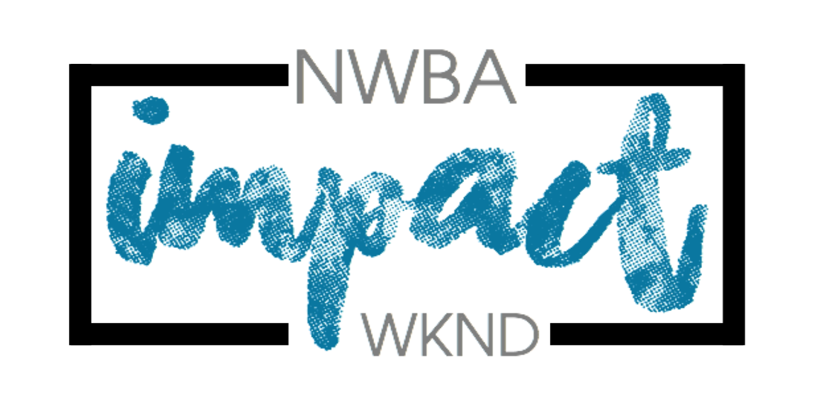

Group Activity Choices
Youth leader to complete with young
people ahead of Impact (by 8th September)

10th - 12th OCTOBER 2025

Please number the activities from 1-8 in order of preference (1 being your highest preference). You will only be allocated 3 activities, and we will do our best to accommodate your top choices if forms are returned on time.
Please return this form by Monday 8th September to Mandy by email impact@nwba.org.uk
If you have registered any young leaders, please include them on this form too, however, they may only be able to do two activities (please make it clear that they are young leaders). All activities last between 60 - 90 minutes.
List and descriptions of activities:

- Waterslide - have fun getting wet down the waterslide.
- Swimming - Jump on in, the water is lovely in this heated indoor swimming pool! One leader per group should be present - this can either be at the side of the pool or in the pool.
- Stand-up Paddle Boards - take part in the latest most popular water sport, and try and stay on your feet, if you can!
- Kayaking - Come and have fun playing games on sit-on-top kayaks
- Frisbee Golf – Throw your discs around the course into the target baskets. Players compete against each other to complete each hole in the fewest number of throws. This is a great way to explore the grounds at Quinta.
- Archery Tag – take up your bows and arrows, put on your face masks and try not to get hit by the opposite team!
- Indoor activities – More relaxed time to do some crafts, learn some circus skills, indoor archery, chat, or play some indoor games
- Climbing Wall - NEW FOR 2025 – How fast can you climb our mobile climbing wall. complete various climbing challenges such as speed climbing and blindfolded climbing.

Name of church:
Name of participant | Waterslide | Swimming | Paddle Boards | Kayaking | Frisbee Golf | Archery tag | Indoor Activities | Tree Climbing
Young Leader
Young Leader
Leader
Leader

Group Activity Choices

Please number the activities from 1-8 in order of preference (1 being your highest preference). You will only be allocated 3 activities, and we will do our best to accommodate your top choices if forms are returned on time.

